league roster – Boys Basketball

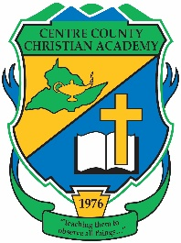


Centre County Christian Academy
Team Colors: Green & Gold
Wins ______ Losses _______ Ties ______
Opponent: ___________________________
Date: ______________________
 |  |  |  |  | Homeschool
3 | Cody Barton | 12th | Guard |  | X
1 | Mitchell White | 12th | Guard
14 | Elliot Pimentel | 11th | Guard
11 | Ben Rossman | 11th | Forward
0 | Grant Smith | 11th | Forward
4 | Josiah Pimentel | 9th | Guard
24 | Jac Cool | 8th | Guard
12 | Carter Barton | 7th | Guard |  | X
5 | Julian Shvenke | 7th | Guard

Head Coach: Rick Gilbaugh
Assistant Coach: Kurtis Gilbaugh

Official ACAA League Team Roster. to be submitted to the scorer’s table before each game.

